*Florida International University*

*School of Computing and Information Sciences*

Software Engineering Focus

Feature Document

User Story ID #332

**Name:** Add Shift Functionality for Officers

**Team Member(s):** Darilys Pereira

**Project:** Virtual Roll Call 4.0

**Product Owner(s)**: Jason Cohen

**Mentor(s)**: Juan Caraballo

**Instructor**: Masoud Sadjadi

**User Story Name:** Add Shift Functionality for Officers

* Description: **As a** administrator **I would like** to assign officers to a specific work shift **so that** I can restrict the access to certain areas of the application based on their shift.

Acceptance Criteria

* Shifts must be setup before being assigned to the officers.
* Shifts can be updated/deleted at any time.
* Officers must be assigned to a specific shift.
* Administrators can change an officer’s shift at any time.

**Use Case**

* Name: Add Shift
* Actor: Administrator
* Preconditions

1. System is up and running
2. Administrator has successfully logged into the system.
3. Connection to the database has been established.

* Description:

1. Administrator clicks the Shift Management option in the system
2. Administrator enters the shift name, start and end time, and status (Active or Inactive)
3. Administrator clicks the Add Shift button.
4. After shift is setup, administrator might want to update the shift for a specific officer to the newly create shift.

**Use Case Diagram**

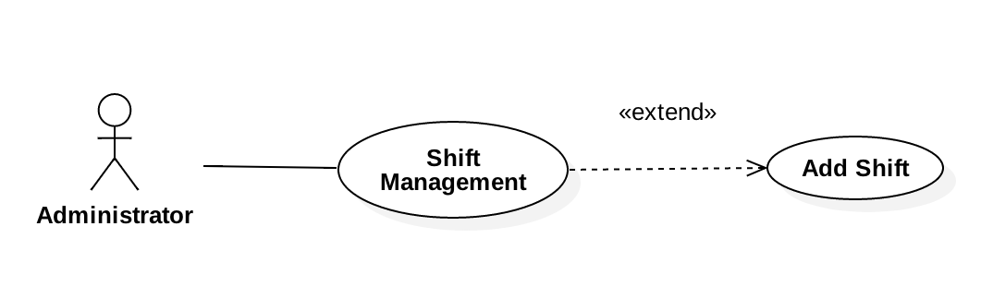

**Sequence Diagram**

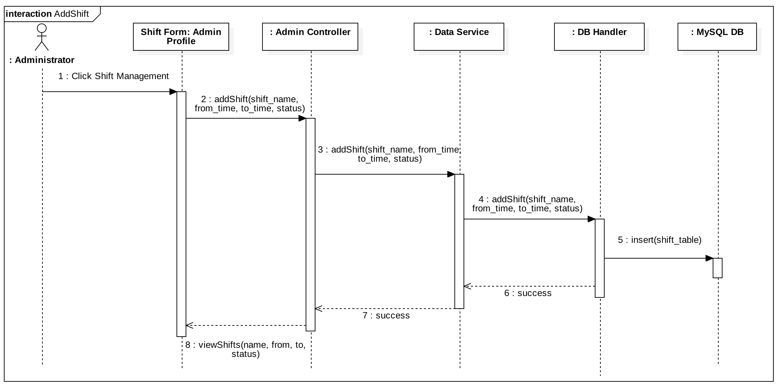

**Class Diagram**

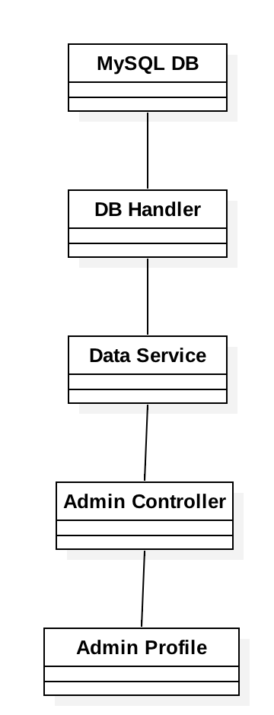

**Unit Test**

Test 1

* Test case ID: User Story #332 - Add Shift - Sunny Day
* Description/Summary of Test: Verify a new shift is added to the database when user attempts to create it using the user interface.
* Pre-condition:

1. User is logged in.
2. User is in Shift Management Page

* Expected Results: User enters the shift information in the form and by clicking the Save button a new shift is created in the database and automatically displayed in the Edit Shift section.
* Actual Result: New shift is successfully saved in the database and populated in the Edit Shift section of the Shift Management page.
* Status (Fail/Pass): Passed

Test 2

* Test case ID: User Story #332 - Add Shift - Rainy Day
* Description/Summary of Test: Verify a new shift can’t be added without specifying the shift name, from, to, and status fields.
* Pre-condition:

1. User is logged in.
2. User is in Shift Management Page

* Expected Results: If user leaves any of the input fields empty a message should be displayed advising shift wasn’t added.
* Actual Result: Warning message was displayed to the user when one of the fields was not populated. Shift was not created in the database.
* Status (Fail/Pass): Passed

**Integration Test**  
Tested system by:

1. Creating a new shift.
2. Editing a shift.
3. Deleting a shift.
4. Created a new user and verified that the list of shift available were all active.
5. Modified an existing user and updated shift information.
6. Logged out and logged back in to verified shift and officer data was persistent in the application.
7. Navigated through the different views of the application verifying existing functionality.

Results: All modules of the application behaved as expected after the new functionality was developed.

Status (fail/Passed) : Passed

**Visual User Guide**

